# Airlines Incidents Dashboard

Author: Sathish Manthani | Date: 06/14/2020

## Goal

We are given Airlines fatalities data which has metrics like Incidents, Fatal accidents, and Fatalities for 1985-99 and 2000-14 time periods by airlines. The goal is to visually present the facts as the media was promoting not to air travel. To combat the negative publicity, I was asked to come up with the dashboard to publish internally within the company to begin with.

## Data sources

Airline-safety.csv is the primary data source. I also used “Fatalities and Fatality Rates.csv” data from NHTSA site that was given in the supplemental datasets section.

Variables in airlines-safety.csv dataset:

|  |  |
| --- | --- |
| **Header** | **Definition** |
| Airline | Airline (asterisk indicates that regional subsidiaries are included) |
| avail_seat_km_per_week | Available seat kilometers flown every week |
| incidents_85_99 | Total number of incidents, 1985–1999 |
| fatal_accidents_85_99 | Total number of fatal accidents, 1985–1999 |
| fatalities_85_99 | Total number of fatalities, 1985–1999 |
| incidents_00_14 | Total number of incidents, 2000–2014 |
| fatal_accidents_00_14 | Total number of fatal accidents, 2000–2014 |
| fatalities_00_14 | Total number of fatalities, 2000–2014 |

Variables in the supplemental dataset are:

|  |
| --- |
| * Year |
| * Total Fatalities |
| * Vehicle Miles Traveled (VMT) Millions |
| * Fatality Rate per 100 Million VMT |

I also gathered the names of First World countries from web and used them as dataset to show how safer air travel is in First world airlines compared to rest of the airlines.

Before visualizing the dataset, I created calculated fields for each of the metrics. I divided the incidents, fatal accidents and fatalities by the Average seat kilometers(ASK) to normalize the data.

## Dashboard

I used Tableau visualization tool to create the dashboard. I imported all 3 datasets and connected them.

I created 4 graphs and 3 metrics. I briefly explained each graph below:

1. **Top 5 Fatalities for 2000-14 by Airline:**

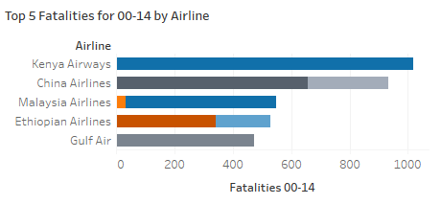

In this graph I took Airlines as dimension and Top 5 Fatalities occurred in 2000-14 as primary metric. I also added fatalities count for these airlines in 1985-99-time frame.

From the graph, Kenya Airlines has high fatalities in 2000-14 but didn’t have any fatality in prior period. China Airlines looks to be unsafe to travel as it has fatalities in both time frames.

1. **Top 10 Fatal accidents:**

I wanted to show if the airlines who had fatal accidents consistently across time periods.

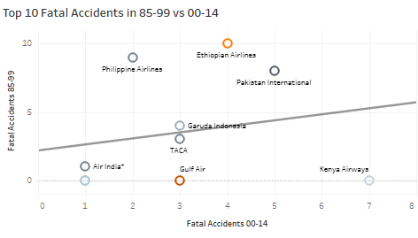

I also drew trend line in this graph. Airlines that are above the trend line seems to have fatal accidents consistently. So, they are unsafe to travel. Airlines below the trend line mostly did not have fatal accidents in 85-99 timeframe.

1. **First world airlines:**

Here I wanted to show Incidents, Fatal Accidents and Fatalities in the airlines that are operated by First World countries.

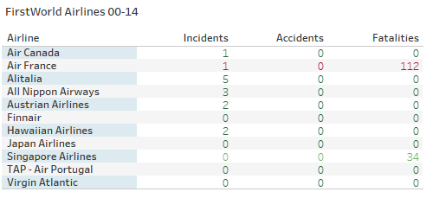

From the graph, it is pretty evident that except couple of airlines there are no major incidents in most of them. So, airlines operated from First world countries are safe to travel. It is probably because of better safety measures and upgraded airplanes.

1. **Vehicle Fatalities:**

This graph from the supplemental dataset. I took the same time as airline-safety dataset.

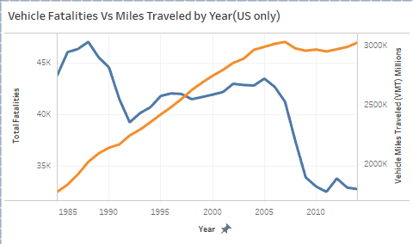

I drew Fatalities and Vehicle miles in this time series graph. As we can see, Fatalities came down as we progressed from 1985 to 2014. That’s probably because of better road safety measures, transportation infrastructure and better vehicles. That being said, if you compare these fatality numbers to airlines then airlines had less

1. **Other Fatality metrics**

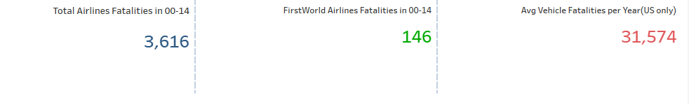

These metrics shows us that Vehicle traveling not safer than air travel. Traveling in First World airlines is safer compared to other airlines.

**References:**

[1] <https://www.nhtsa.gov/research-data/fatality-analysis-reporting-system-fars>

[2] <https://github.com/fivethirtyeight>

[3] <https://github.com/fivethirtyeight/data/tree/master/airline-safety>

[4] <https://fivethirtyeight.com/features/should-travelers-avoid-flying-airlines-that-have-had-crashes-in-the-past/>